Date: 16 September 2020

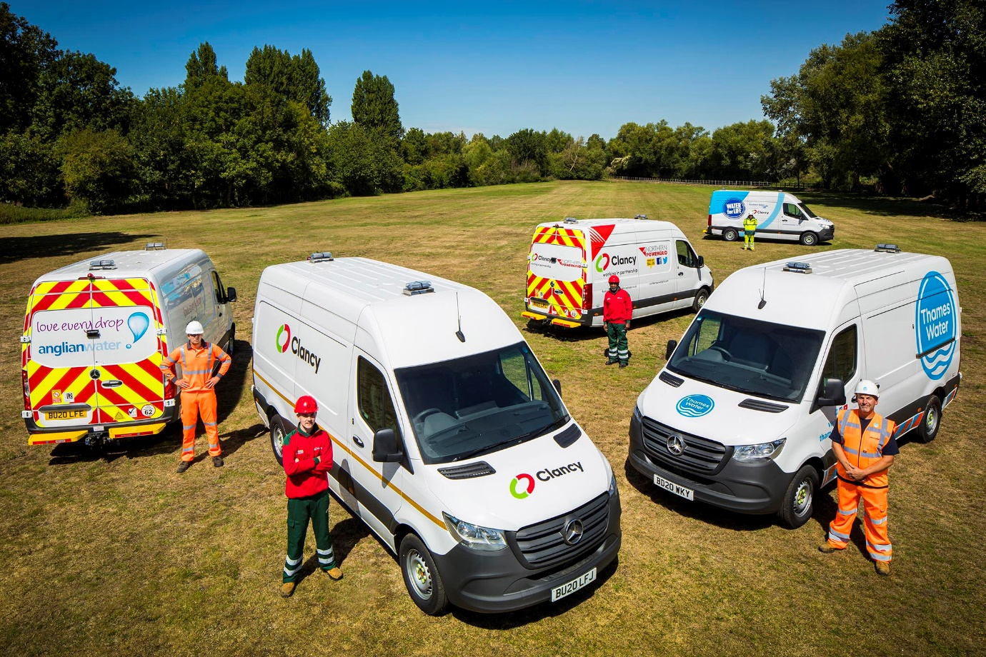

Brand associations: Clancy Group’s Mercedes-Benz Sprinters wear the liveries of high-profile businesses for which the leading contractor works

Utilities contractor Clancy Group pipes in a new fleet of Mercedes-Benz Vans

Leading Utilities Contractor Clancy Group has entrusted Mercedes-Benz Dealer Midlands Truck & Van with a landmark order for more than 500 light commercial vehicles, which are now supporting some of the country’s biggest and best-known service providers.

Most are Sprinter models with ground-breaking Mercedes PRO connect technology, which the operator is confidently predicting will deliver “a step change” in its fleet management capability.

Clancy Group switched to the three-pointed star just over four years ago and has not looked back since. “Our Mercedes-Benz vans have proved to be far more reliable than those we’d operated previously,” explained Head of Clancy Plant David Janes.

“That’s a key quality in this industry – we need our vehicles to be out there and working, so the fact that they are hardly ever off the road for anything other than routine maintenance is crucial. They’ve also been impressively cost-effective to operate, across a tough working regime in which each averages around 30,000 miles per year.”

Mercedes PRO connect uses 4G Internet technology to provide operators with access to a range of fast, efficient and cost-effective fleet management service packages.

Mr Janes added: “We see great potential in the way PRO connect can help us by collecting a raft of highly detailed information on the way our vehicles are working. These are early days, and we’re only just beginning to explore the ways in which we can best use the system, but we believe it will enable a significant improvement in the way we manage our
Mercedes-Benz van fleet.”

He continued: “The final piece of the jigsaw is the relationship. We receive excellent back-up from the manufacturer and its Dealer. Over the last four years Midlands Truck & Van’s Account Manager Erica Stredwick has developed a highly detailed understanding of our operation, and of our specific requirements.

“Having a dedicated Account Manager proves to us the commitment of our supply chain; we are assured there is always someone there who knows our business as well as we do, who thinks the way we do, and can make things happen when needed.

“We can place an order and not need to worry about it, because Erica is there in the background, seamlessly arranging conversions and the fitment of additional equipment, as well as the application of customer-specific liveries. We also benefitted from a visit by the Dealer’s Connectivity Specialist Michael Carolan, who was able to give us a detailed explanation of the various ways in which PRO connect can help in our day-to-day operations. That kind of service is priceless.”

The vehicles are operated by Clancy Plant, and are now hard at work on contracts held by other Group divisions, whose customers include many of the UK’s leading utility providers. They wear several different liveries, some of which bear the names and logos of the businesses Clancy Group supports.

The 553 units delivered this year include examples from across the entire Mercedes-Benz Vans range. The majority – 445 in total – are 3.5-tonne Sprinter 316 CDI panel vans and chassis cabs, the latter being fitted with tipping or dropside bodies, or access platforms. Midlands Truck & Van has also delivered 84 mid-sized Vito vans, 20 smaller Citans, and four X-Class pickups.

Most of the Sprinter panel vans were specified with 7G-TRONIC PLUS automatic transmissions, to make life easier for drivers working in urban environments. They are equipped with compressors and generators by On-Board Power, of Liversedge, West Yorkshire.

“Typically, these vans transport the teams who dig holes in the road, together with all their tools and equipment, which frequently includes excavators towed on trailers,” explained Mr Janes. “Others are kitted out as rapid response vehicles – if a burst water main is reported, for example, specialist teams have to react to the call-out within two hours.”

He continued: “The Vito vans carry out similar tasks to the Sprinters, but are deployed at locations which are better suited to a more compact vehicle, while the Citans and X-Class pickups are allocated to roles such as leak detection and meter fitting, or to supervisors.”

“Although these vans come in a variety of shapes and sizes, they share the same attributes of outstanding build quality, reliability, economy, comfort and impressive safety specifications, as well as first-class aftersales support. Whichever way you look at it, Mercedes-Benz vehicles are far better than any we’ve operated in the past.”

Multi-award-winning Clancy Group is one of the largest privately-owned construction firms in the UK. Established in 1958, the company now provides employment for more than 2,500 colleagues, who provide infrastructure and related services to customers the length and breadth of the UK.

www.theclancygroup.co.uk

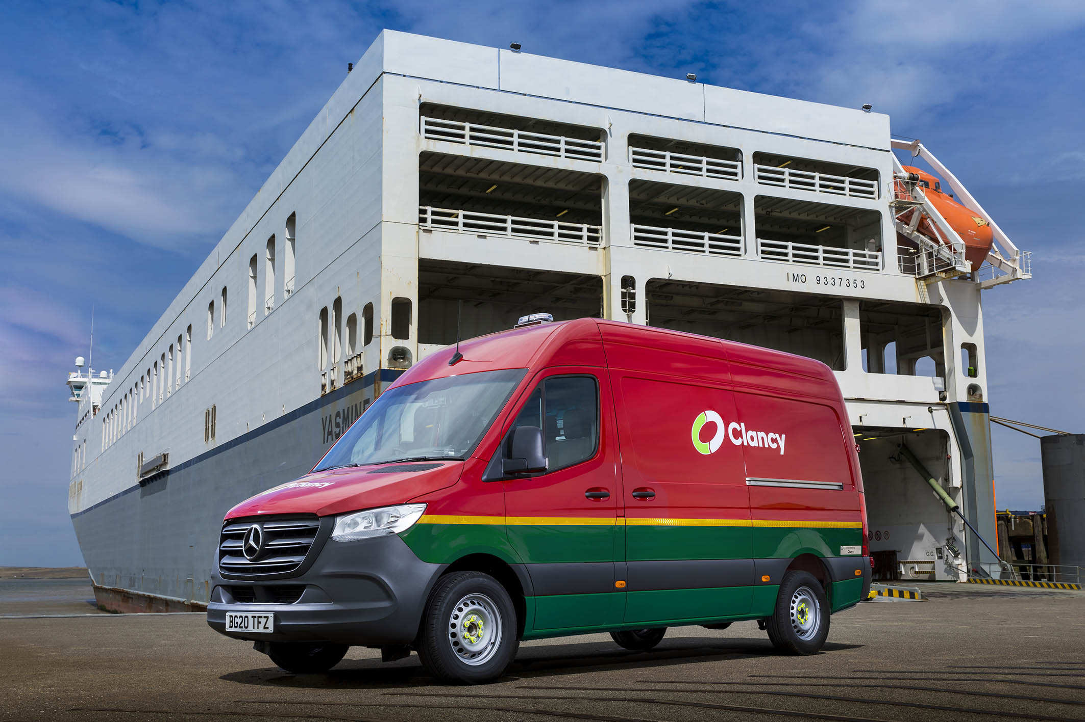

Home strip: Some of Clancy’s Sprinters work in the company’s own colours…

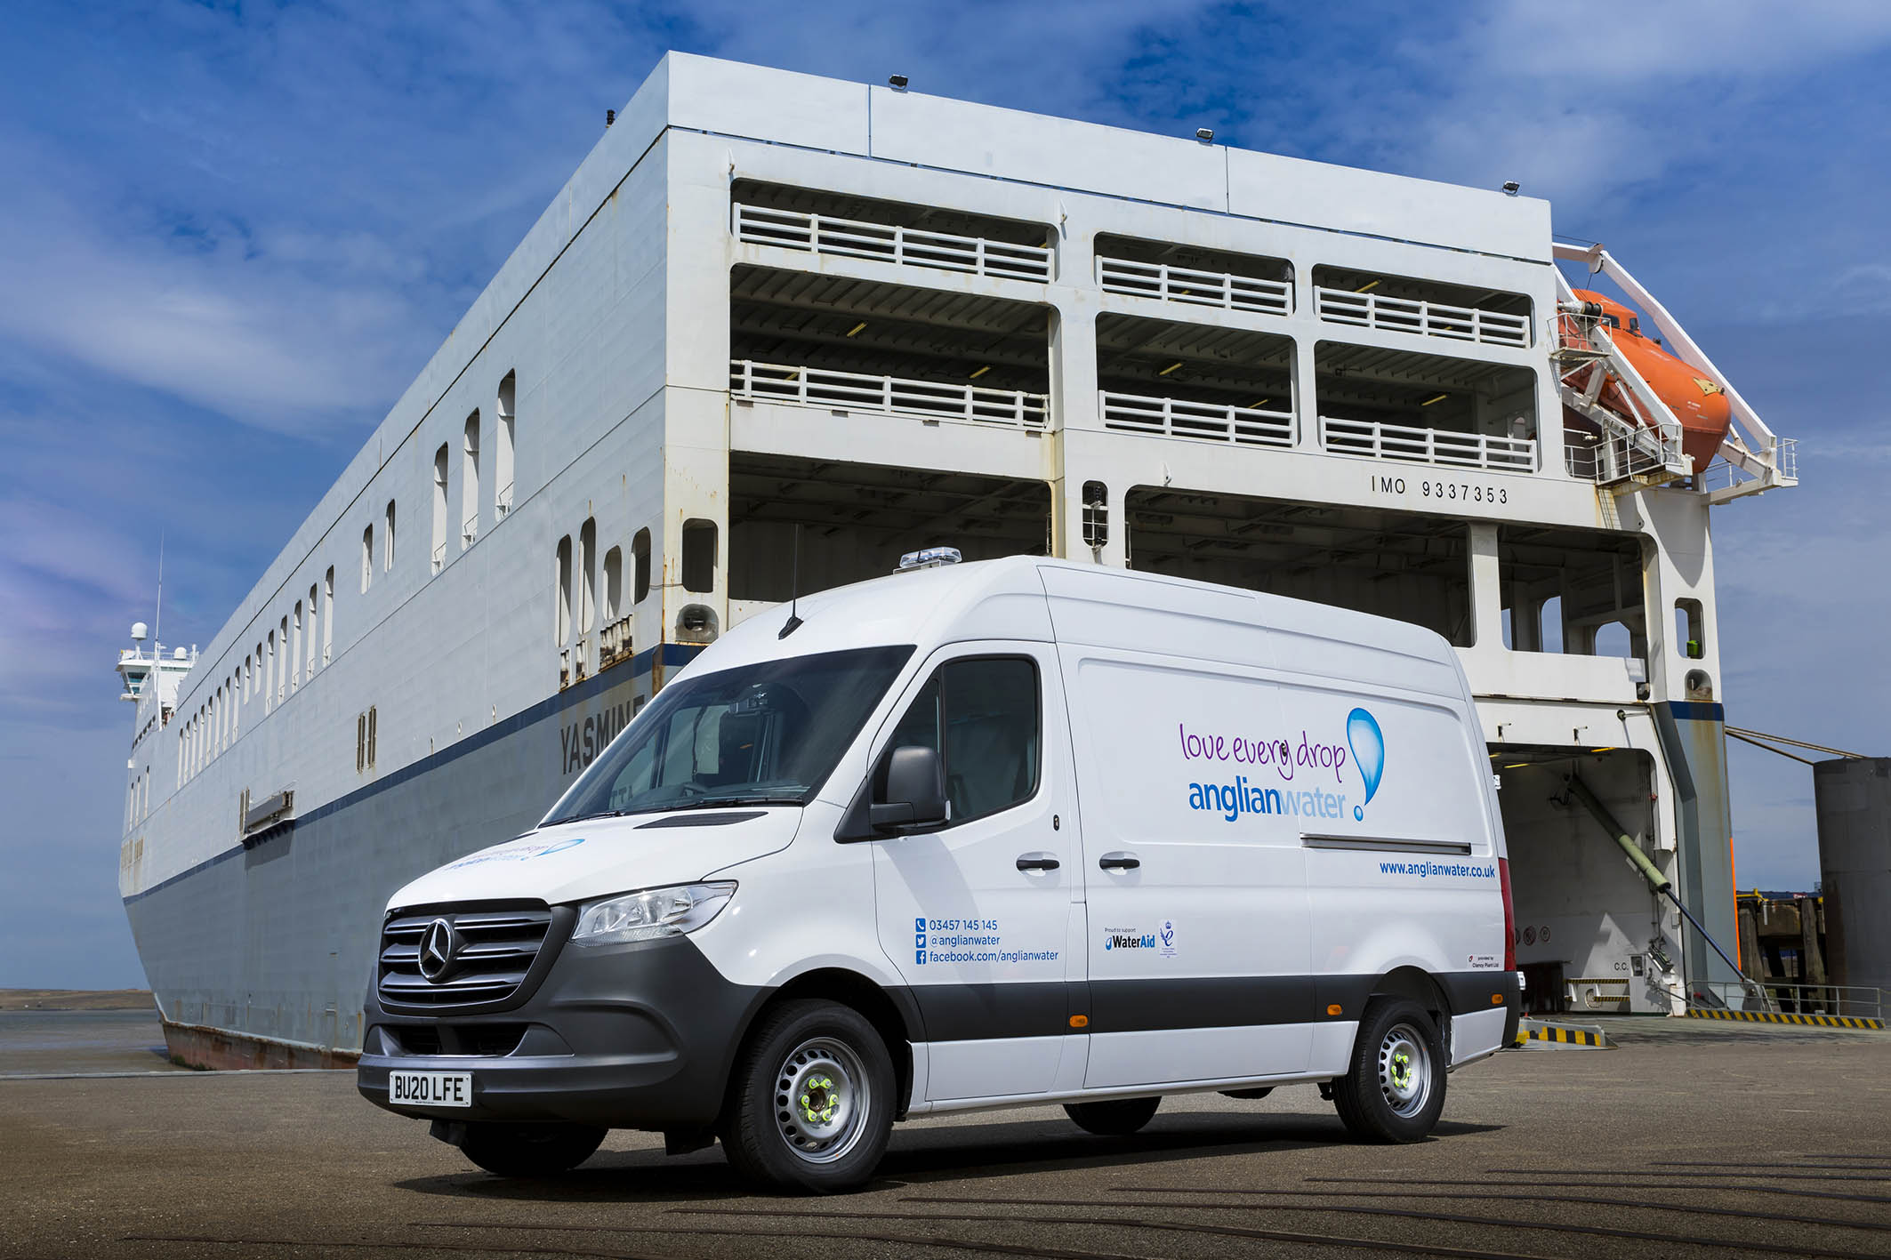

Eastern promise: While others wear the liveries of high-profile customers such as Anglian Water

ends

For more information, or to request bigger/higher-res image files, please contact:
Steve Warren or John Ripley
Impact Communications, 01926 842126
Steve: 07770 470251, steve@impactcom.co.uk
John: 07771 484595, john@impactcom.co.uk

